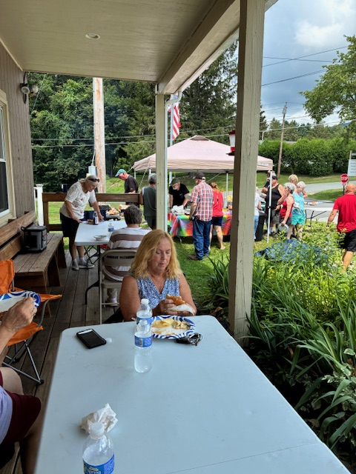
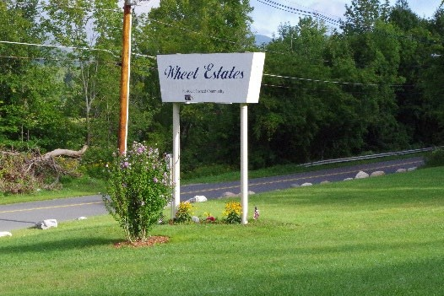
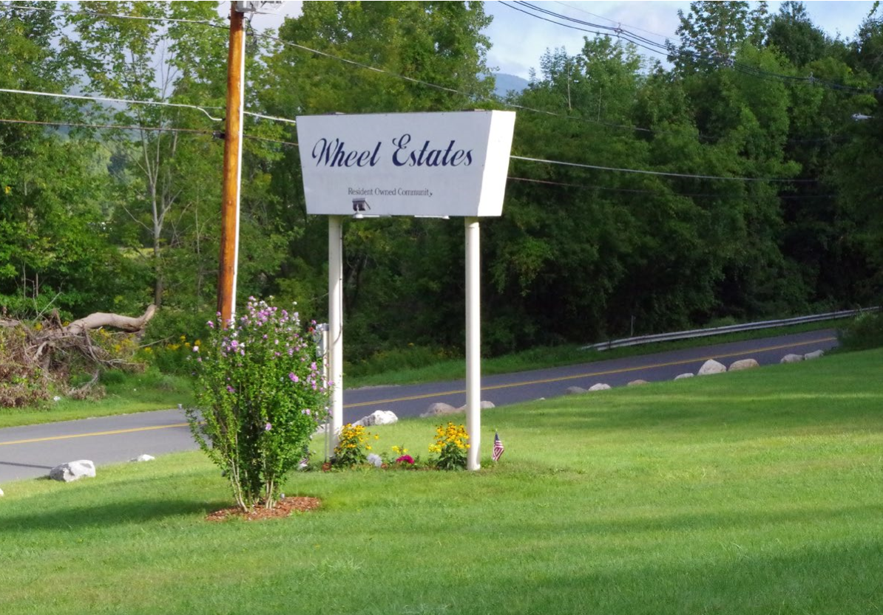

Monthly Newsletter
M

WHEEL ESTATES

NEWSLETTER

Office Phone 413-663-8963

Emergency number 413
-
346
-
8090

AUGUST

MARCH

BER AUGUST

2025

FROM THE BOARD OF DIRECTORS:
This has been another great year for completing projects. Read on for more details!

MEMBERSHIP:
Everyone is encouraged to become a Member. If you haven’t yet joined, please stop into Moresi and bring a check for $100. This money is refunded to you when you leave the community. Membership comes with voting privileges, including electing directors, helping approve the annual budget, and other financial decisions as they arise.

RANDOM QUESTIONS:
How many liters in a gallon?
Why did the chicken cross the road?

COMMITTEES:
We have openings on the following Committees:
Finance, Pool, Special Events,
Beautification, Welcoming.
A note on committees…you can participate as much or as little as you like on the committees!

STREET CAPTAINS
Looking for volunteers to spearhead distribution of informational flyers to residents on a street. Please call or stop in the office if interested.

TRASH PICKUP SCHEDULE:
Trash pickup is on Wednesdays.

POOL:
Residents should all have a pool pass. If not, please stop in to the office to secure one. Residents must be present at the pool with their guests and bring their pass. Rinsing showers must be taken before entering the pool. This helps maintain the water quality. Thank you!

PUMP HOUSE REPORT:
We are excited to say this is now complete! Most if not all residents should have better service than before. The system provides a better, more reliable, and smoother operation, putting less strain on our water lines.

ENTRANCE ROAD WATER LEAKS
As we all know, we have had 2 issues with water leaks under the entrance road. Back in winter, there was an actual break in the pipe. The most recent issue was the pipe deteriorating so much the water was just shooting up out of it. We will be holding a special meeting of the shareholders to discuss replacing that section of pipe so we don’t have to keep ripping up the road to fix it.

INFILL COMMITTEE UPDATE:
Demolition was completed for the homes at 21 and 24 Apache. Plans are already underway for developing 21 and 24 Apache. A new home has arrived at 2 Seneca Drive. It will be live in ready very shortly. There are homes on order for 42 Apache, 8 Apache, 12 Aztec, 24 Apache and 7 Iroquois Drive. Some will arrive in late August, others likely in September. Stay tuned!

ELECTRICAL METER WORK:
This is now finished. Yippee!!

SPECIAL EVENTS COMMITTEE
The Special Events Committee has the following upcoming events:
Bottle and can drive Saturday 9AM-11AM:
September 6 and December 27.
Potluck dinner: September 7.
Outdoor Flea Market 8AM-4PM August 2.
Halloween Party 530PM-7PM Friday October 31.
Holiday craft fair 9AM-3PM November 15 and 16.
The committee is looking for volunteers to schedule and present some day trips. Come be a part of something fun!
The BBQ was held on Sunday July 13. Over 30 people attended. The special events committee is considering scheduling another…

MEET THE BOARD OF DIRECTORS
PRESIDENT – Jeff Filios
VICE PRESIDENT -Al Bennett
TREASURER -Sandy Overlock
SECRETARY -Jackie Andrews
AT LARGE MEMBERS
Laurie Maximillian
Becky LaFlamme
Liz O’Keefe
Tina Smith
Barb Casuscelli

Please mail or take your rent checks to Moresi &
Associates 60 Roberts Drive Suite 201 North Adams Re: Wheel Estates.

RULES REVIEW
The Rules Committee worked hard to update our current Community Rules. There will be a community meeting to discuss and answer questions about the proposed updates.

FEEDING ANIMALS
As a reminder, other than bird feeders or suet feeders, residents should not be feeding wild animals. This causes an issue with wildlife coming into the community, and some of the wildlife is aggressive towards us and our pets. Thank you!

RESIDENT OWNED COMMUNITY LIVING
A message from the President

WETA wants you! We need great people like you to help keep the momentum going for all the great things that have been happening. You can volunteer in any capacity you like, as little or as much as you like. The more volunteers there are, the more great things we can plan and do!

